**PROJECT AUTOMATION TOOL**

**HOME PAGE:**

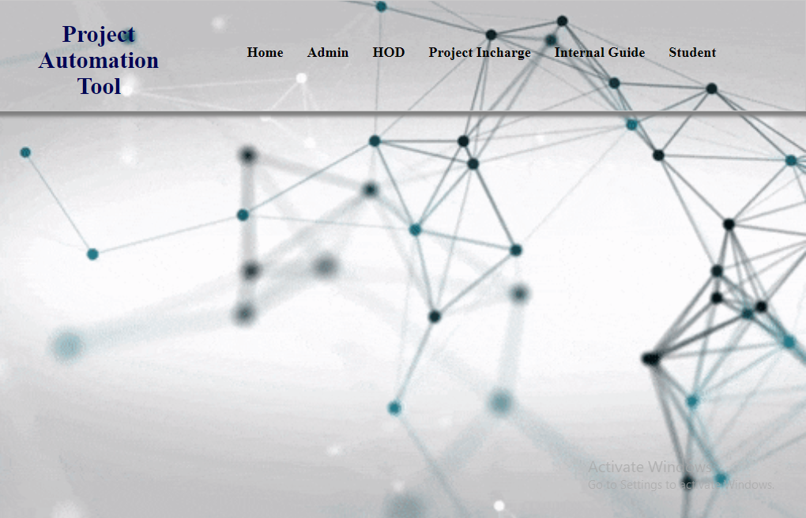

**ADMIN LOGIN:**

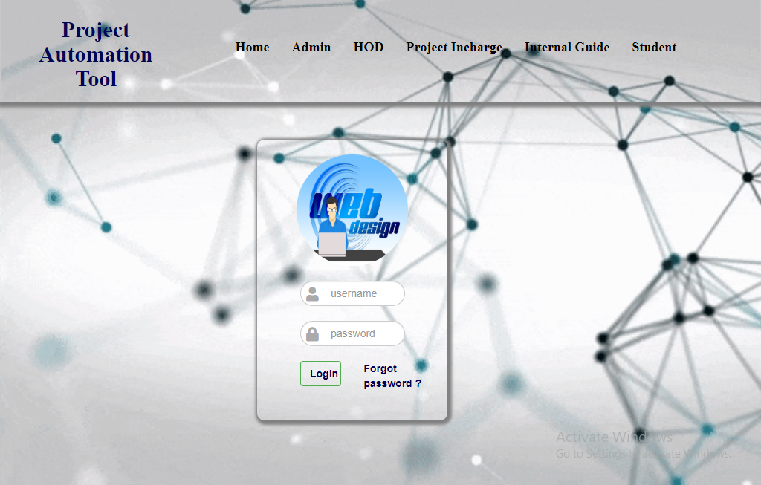

**ADMIN HOME:**

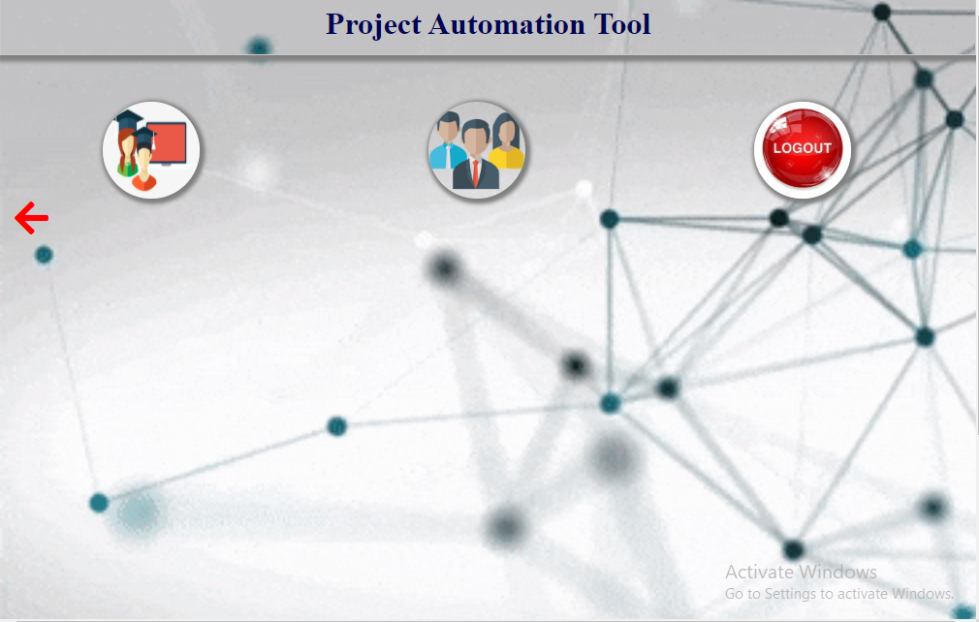

**ADMIN VIEW STUDENTS:**

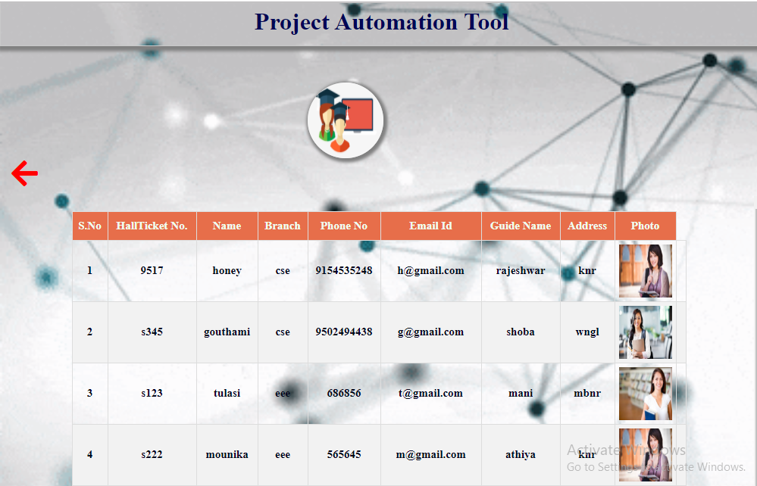

**ADMIN ADD EMPLOYEE:**

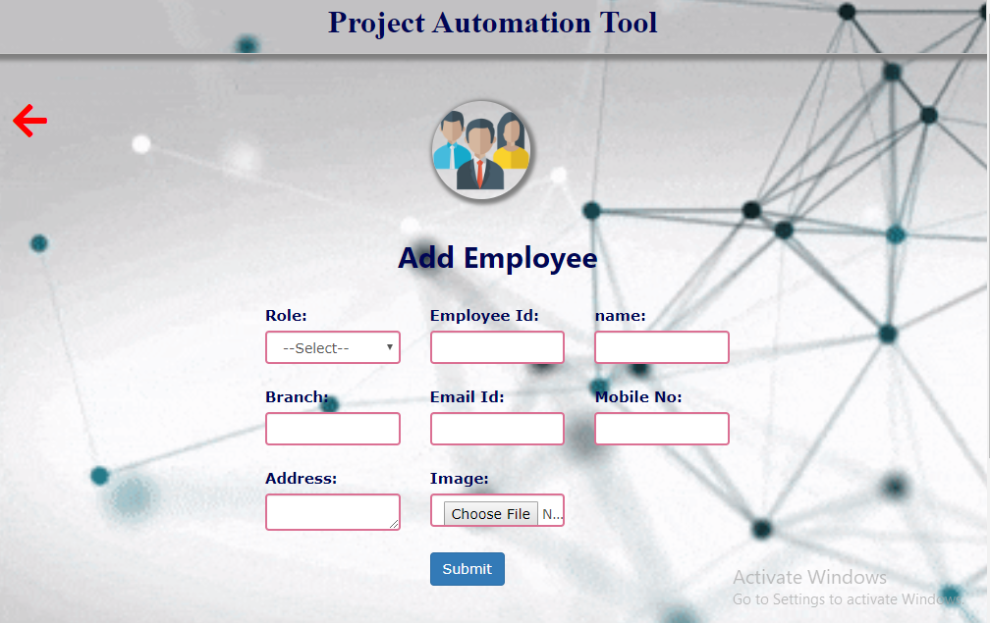

**ADMIN VIEW EMPLOYEES:**

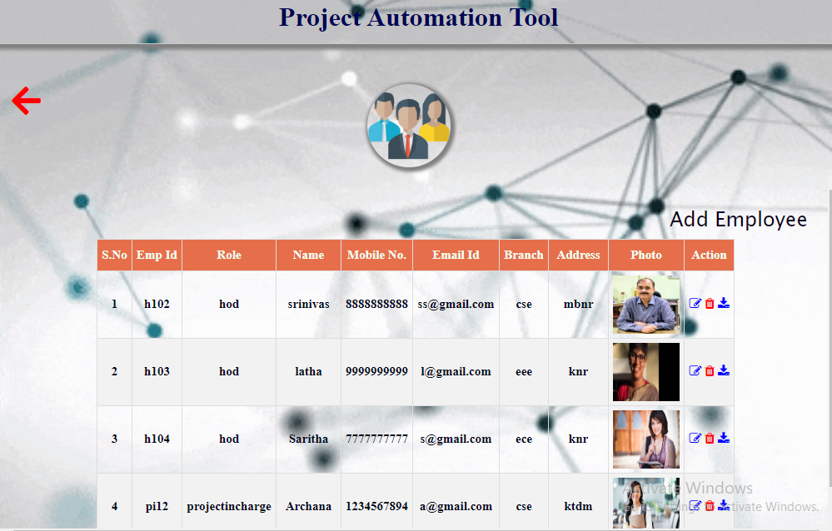

**ADMIN EDIT & UPDATE EMPLOYEES:**

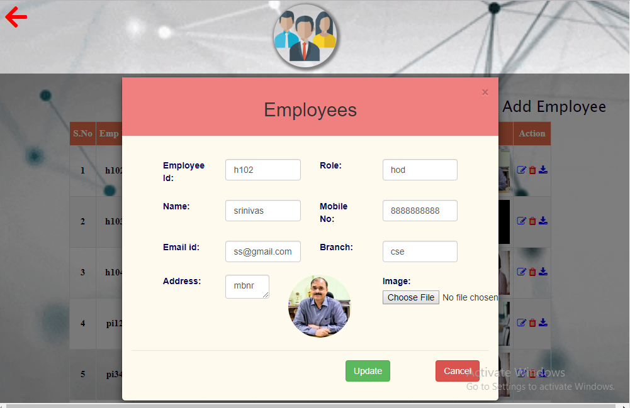

**HOD LOGIN:**

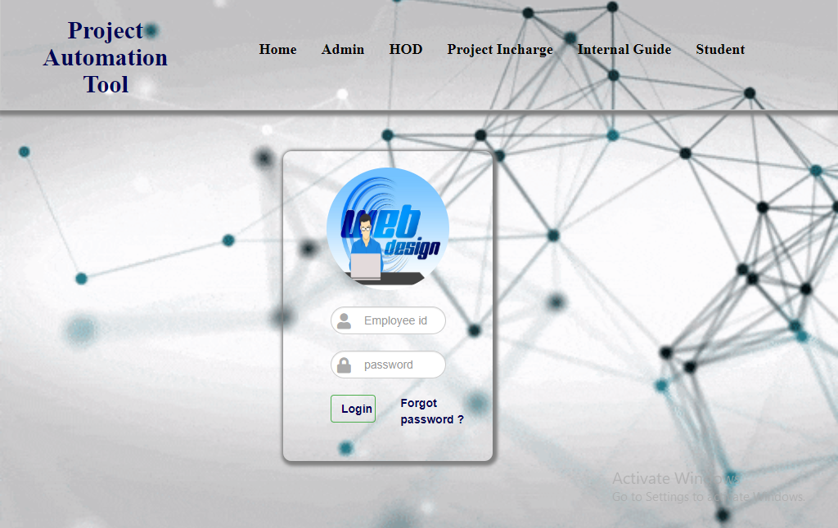

**HOD HOME:**



**HOD PROFILE:**

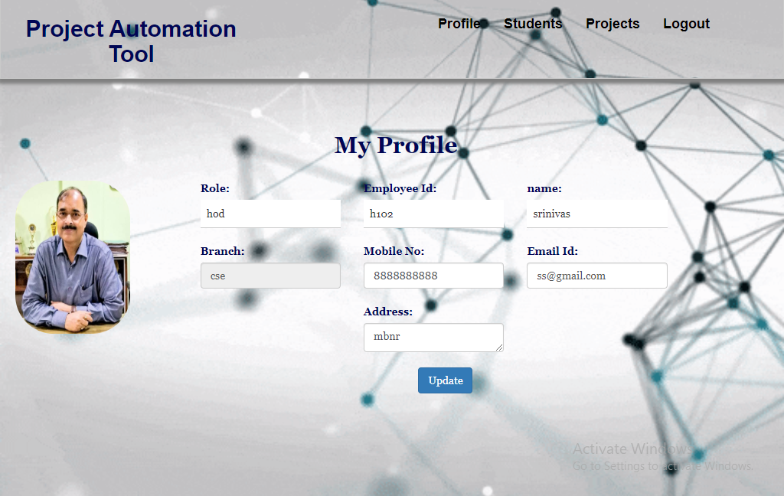

**HOD VIEW STUDENTS:**

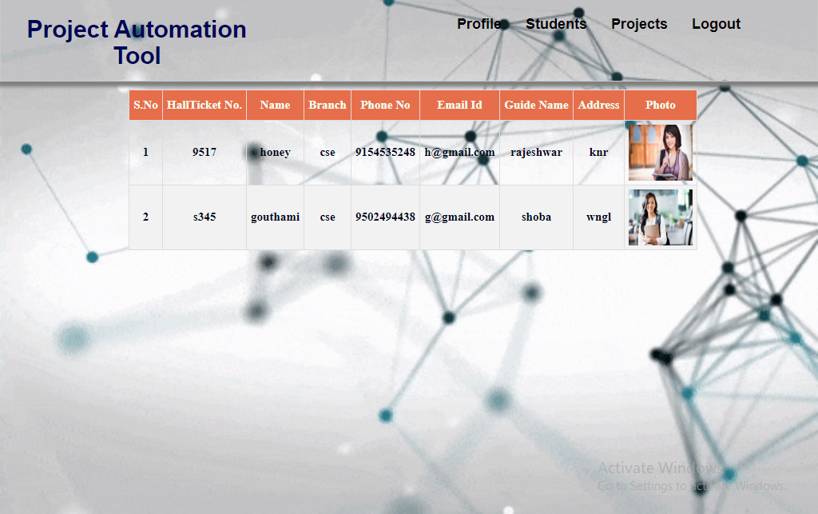

**HOD VIEW PROJECTS:**

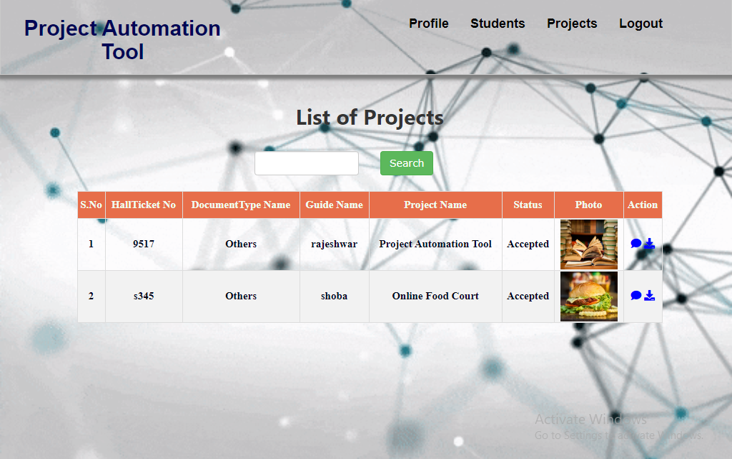

**HOD COMMENTS ON PROJECTS:**

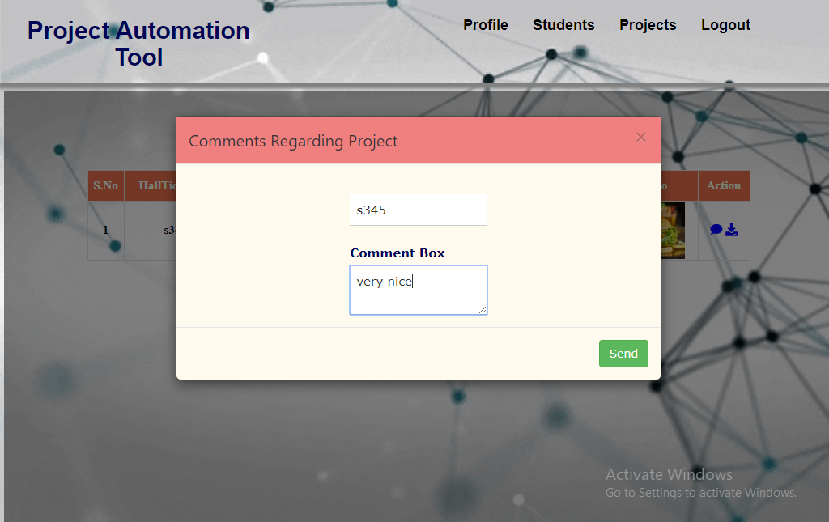

**PROJECT INCHARGE LOGIN:**

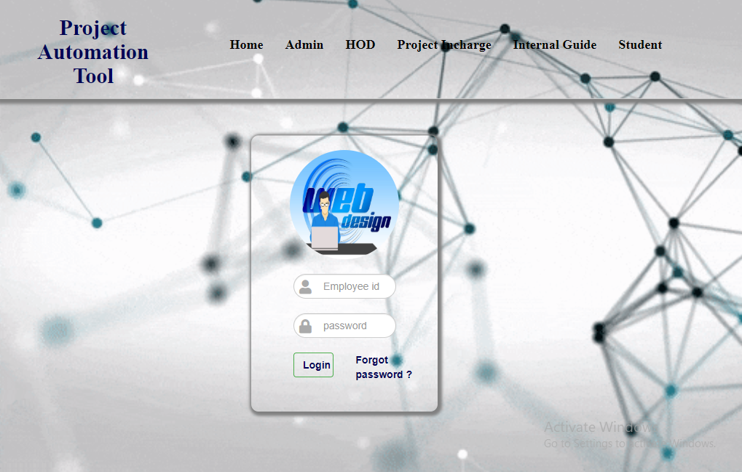

**PROJECT INCHARGE HOME:**

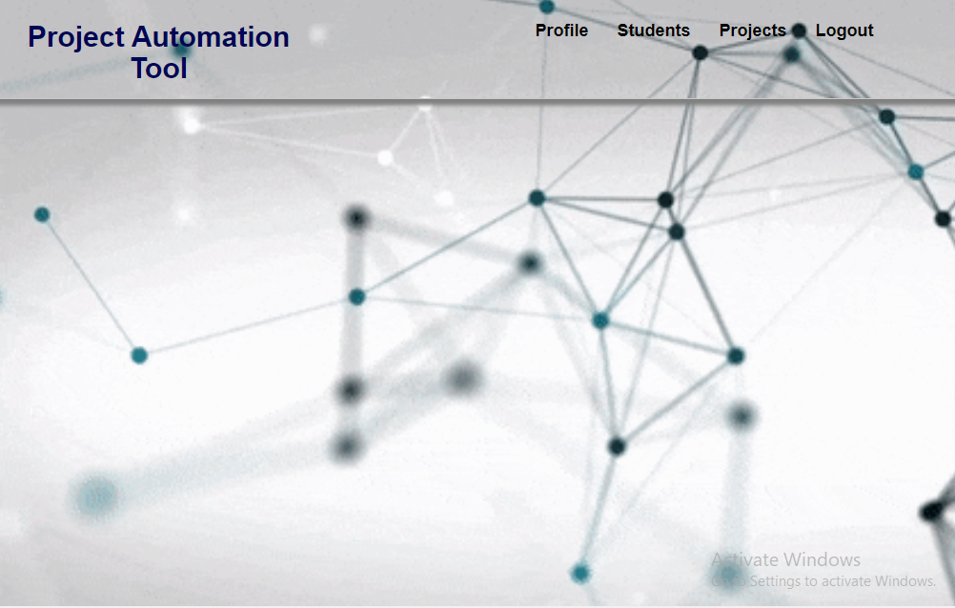

**PROJECT INCHARGE PROFILE:**

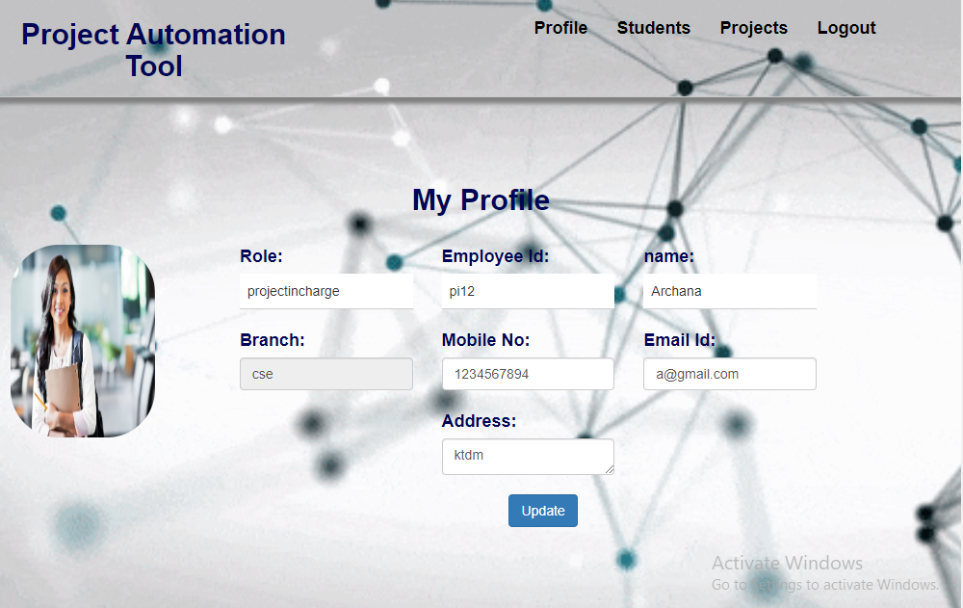

**PROJECT INCHARGE ADD STUDENTS:**

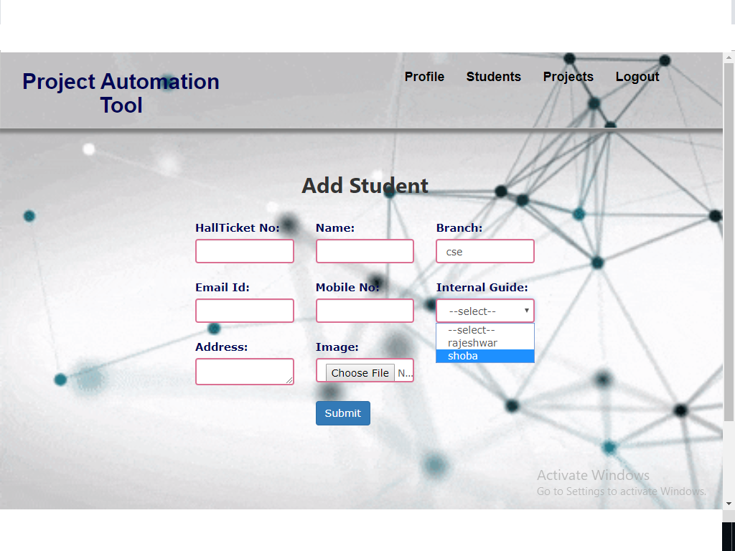

**PROJECT INCHARGE VIEW STUDENTS:**

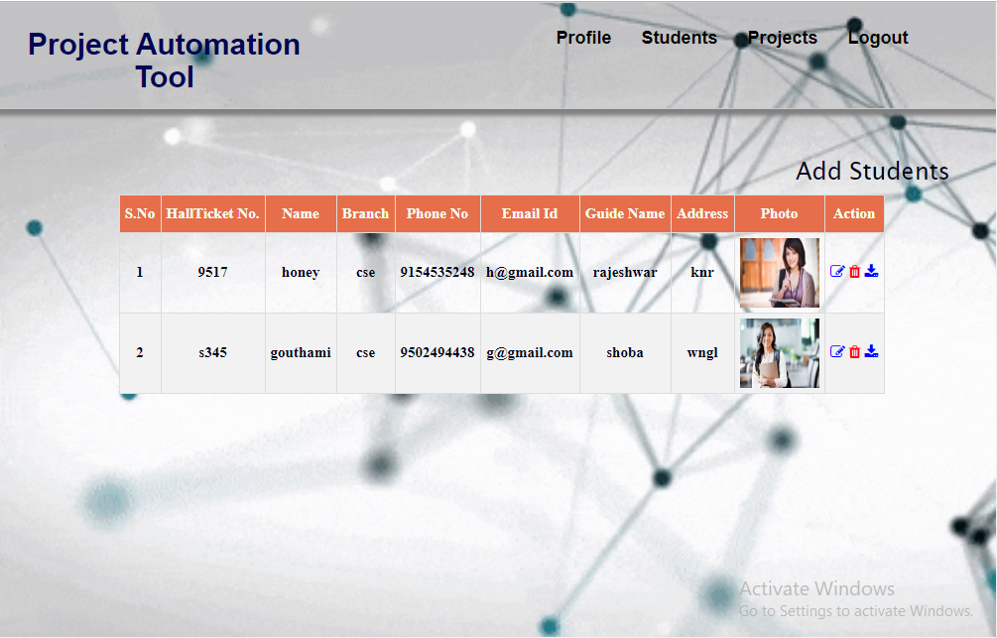

**PROJECT INCHARGE EDIT & UPDATE STUDENT DETAILS:**

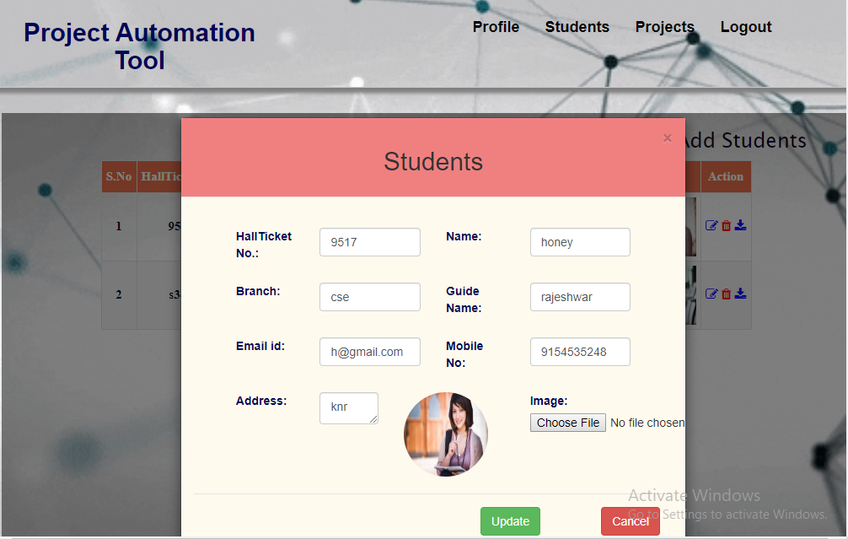

**PROJECT INCHARGE VIEW PROJECTS:**

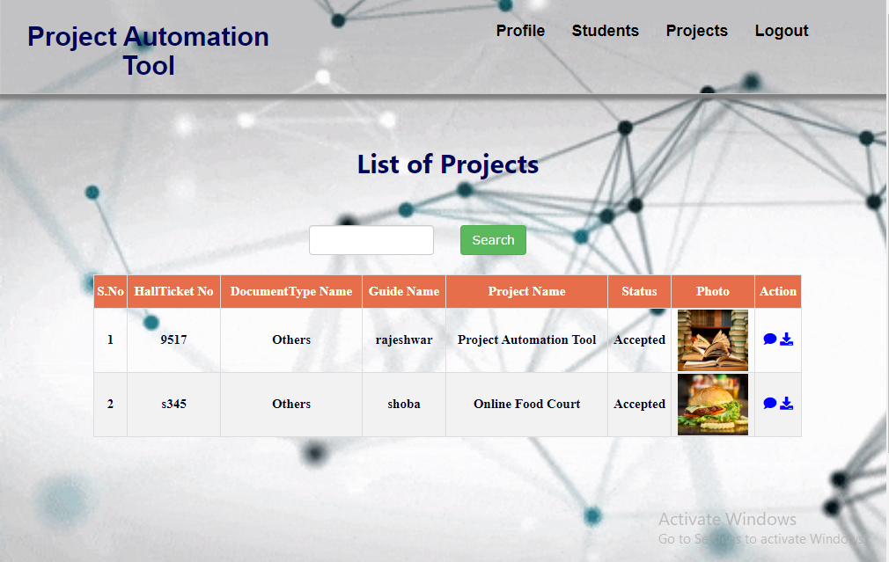

**PROJECT INCHARGE COMMENTS ON STUDENT PROJECT:**

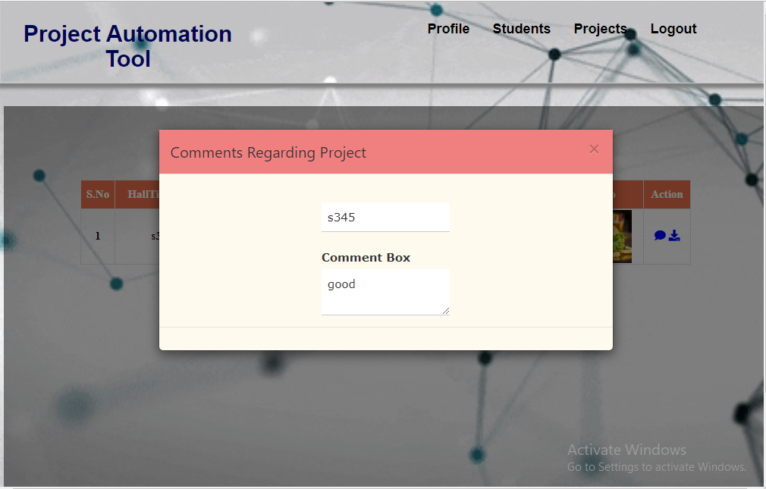

**INTERNAL GUIDE LOGIN:**

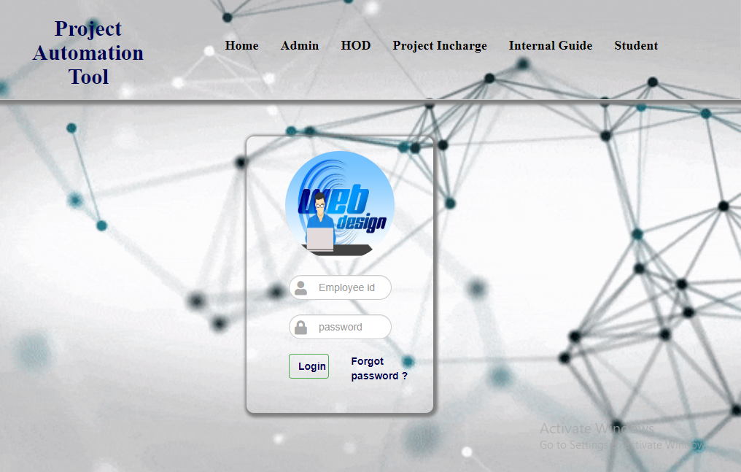

**INTERNAL GUIDE HOME:**



**INTERNAL GUIDE PROFILE:**

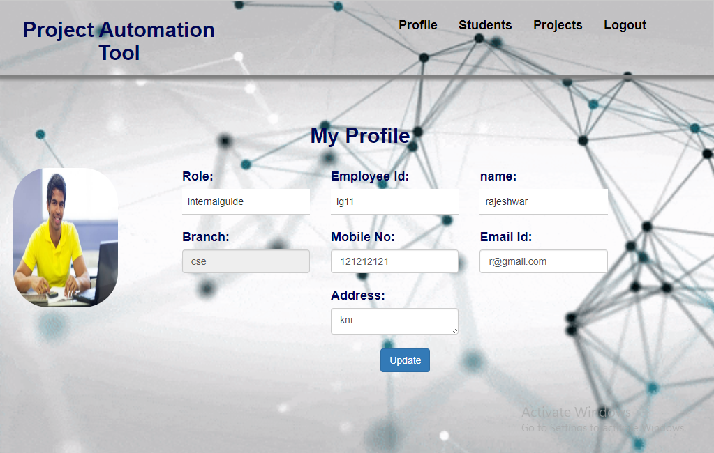

**INTERNAL GUIDE VIEW STUDENTS:**

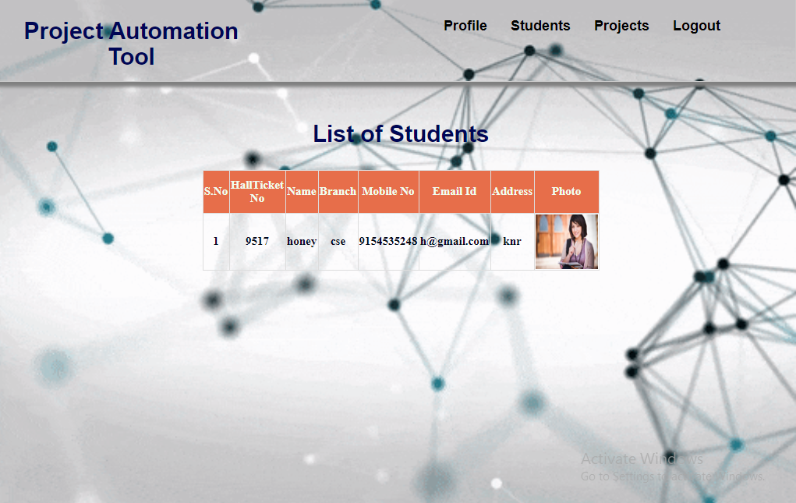

**INTERNAL GUIDE VIEW PROJECTS TO ACCEPT/REJECT THE STUDENT PROJECT:**

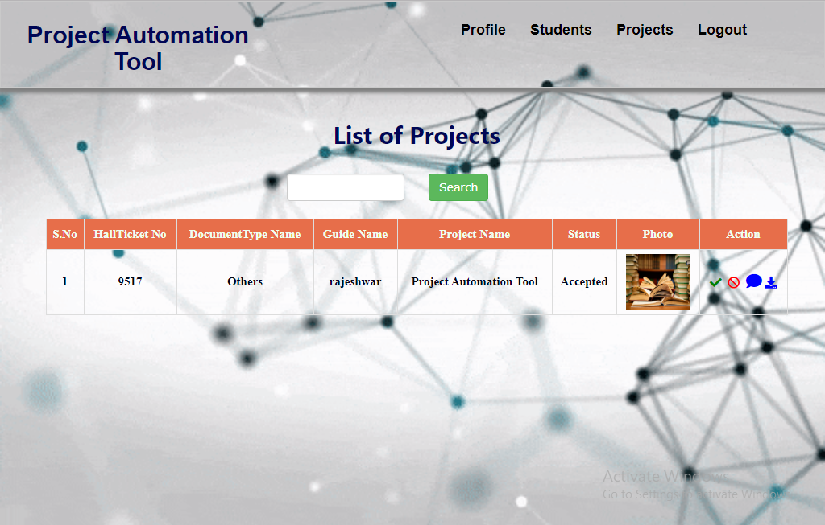

**INTERNAL GUIDE COMMENT ON STUDENT PROJECT:**

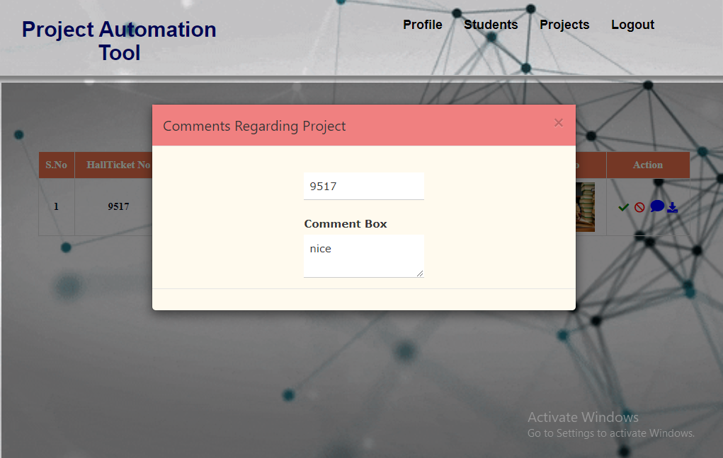

**STUDENT LOGIN PAGE:**

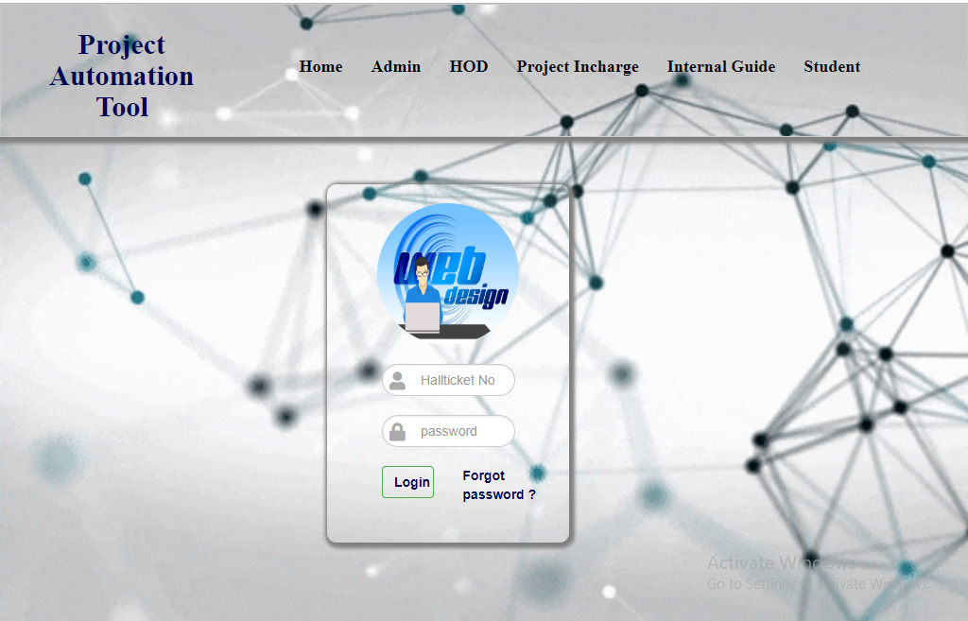

**STUDENT HOME:**

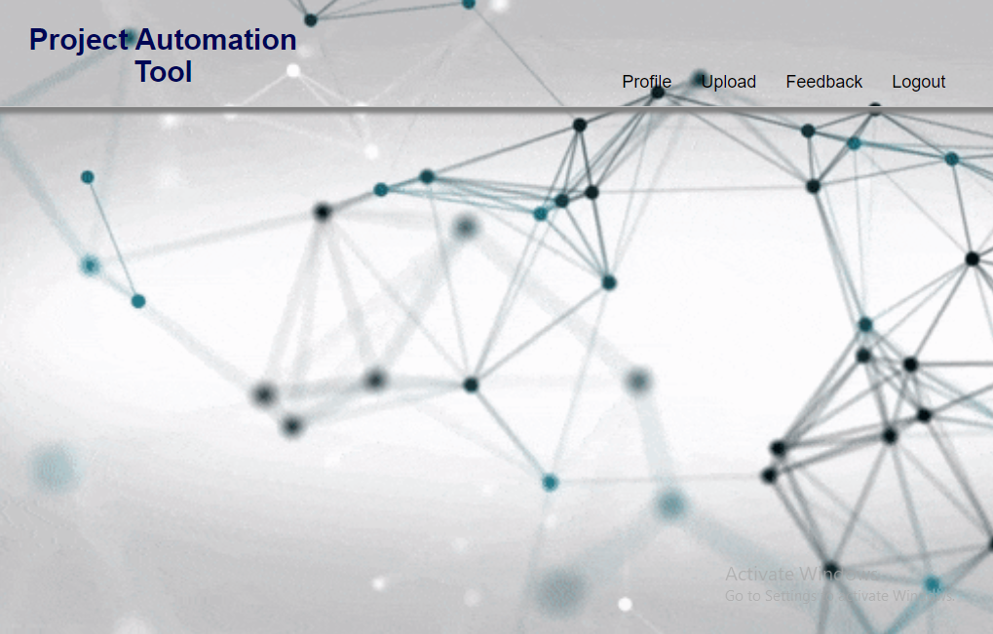

**STUDENT PROFILE:**

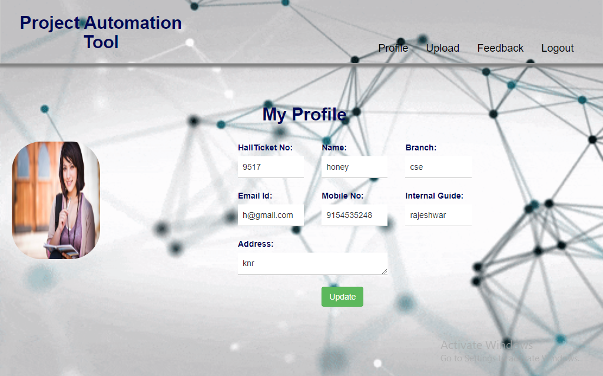

**STUDENT UPLOAD PROJECT:**

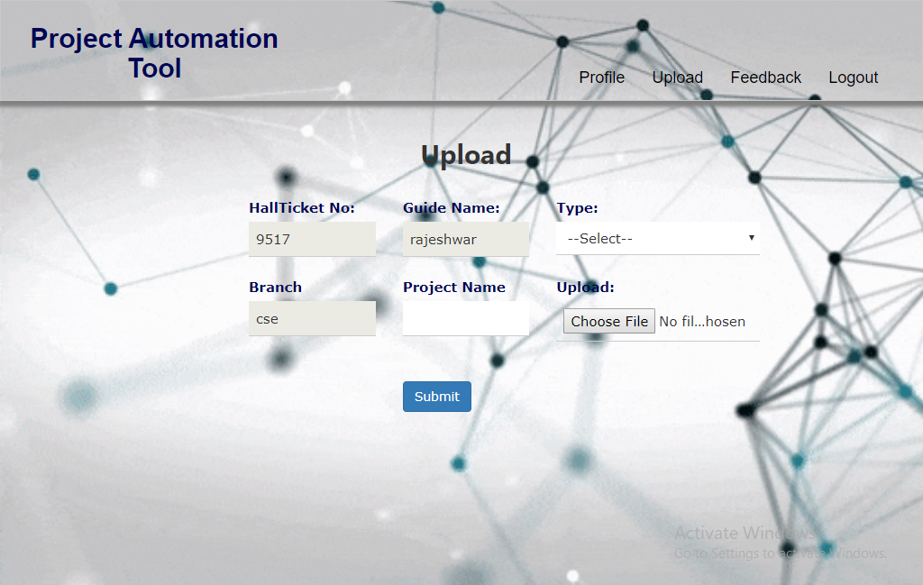

**STUDENT VIEW HIS FEEDBACK:**

